Lab Assignment 1-1 Intro to Linux Linux+ and LPIC-1

1. If you do not already have an SSH client on your system, download putty (or some other SSH client) and install it on your system.
2. Use putty to logon to COIS-Linux.austincc.edu using the user id and password provided to you via Blackboard Message.

3. Enter the command: whoami and show the results in your answer: u7632801

4. Enter the command: ls -la and show the results in your answer
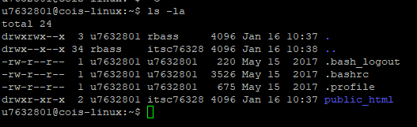

4. Enter the command: cat .profile and show the results.
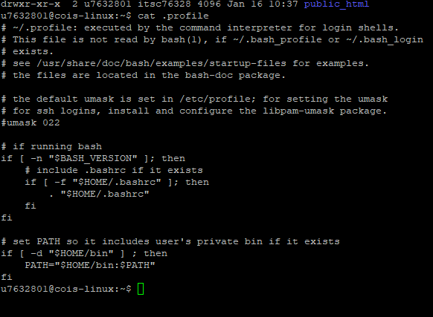

5. Enter the command: pwd and show the results.
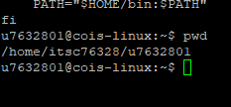

6. Enter the command: who and show the results
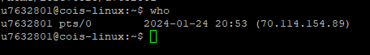

7. Enter the command: w and show the results.
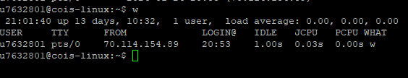

8. Enter the command: file .bashrc and show the results
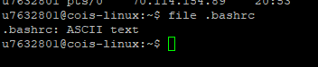
9. Log out of the system by entering the command: exit

